JS Apps Exam – Chirper Single Page Application
You are assigned to implement a Web application (SPA) using HTML5, JavaScript, AJAX, REST and JSON with cloud-based backend (Kinvey). The app keeps users and chirps (tweets). Users can register, login, logout, view feed page (all chirps from followers sorted by time in descending), create a chirp, delete a chirp, view own chirps, discover new people, get all chirps by specific user (sorted by time in descending), follow or unfollow a user.
Using libraries like jQuery, Handlebars and Sammy is allowed but is not obligatory.

Create a Kinvey REST Service
Register at Kinvey.com and create an application to keep your data in the cloud.
Each user has a username, password and subscriptions (array of usernames).
In the Users collection, import the provided JSON file with sample users to get started with template data. In the Kinvey Console, select Users from the navigation of the left, click Settings in the upper right then scroll down to the Import section:
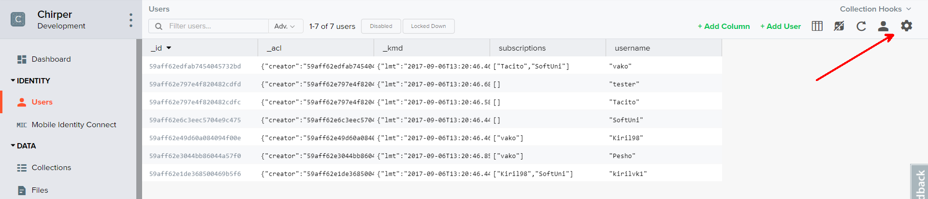
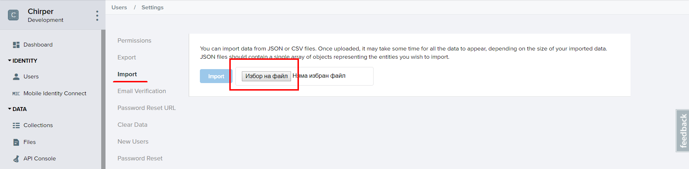
Create a collection chirps. Each chirp has a text (string with max length 150 and cannot be empty) and an author (username of the creator).
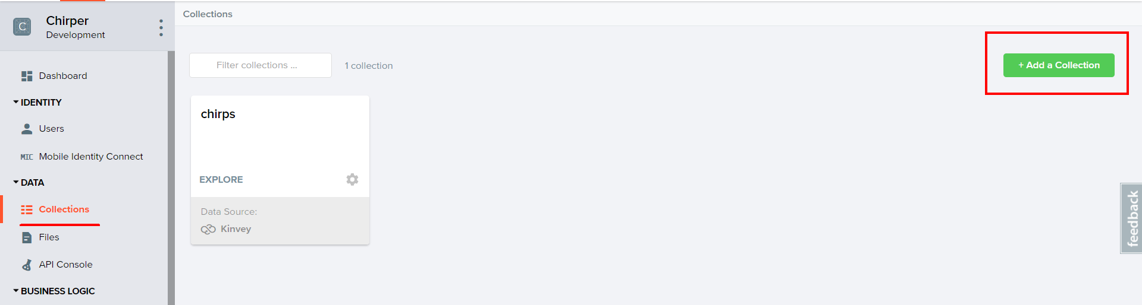
You are also given one more json file to import your chirps.

Test the Kinvey REST Services
Using Postman or other HTTP client tool (you can use Kinvey’s built-in API Console), test the REST service endpoints:

User Registration (Sign Up)
POST https://baas.kinvey.com/user/app_key/
Request headers | Authorization: Basic base64(app_id:app_secret)  Content-Type: application/json
Request body | {  "username": "testuser",  "password": "testuserpass890",  "subscriptions": []  }
Response  201 Created | {  "_id": "59affdae3044bb86044a79bd",  "username": "testuser",  "password": "testuserpass890",  "subscriptions": []  }
Error response  409 Conflict | { "error": "UserAlreadyExists", "description": "This username is already taken. Please retry your request with a different username", "debug": "" }
Error response  401 Unauthorized | { "error": "InvalidCredentials", "description": "Invalid credentials. Please retry your request with correct credentials", "debug": "" }
The request needs “Basic” authentication. Use the Kinvey App Key and Kinvey App Secret as credentials.
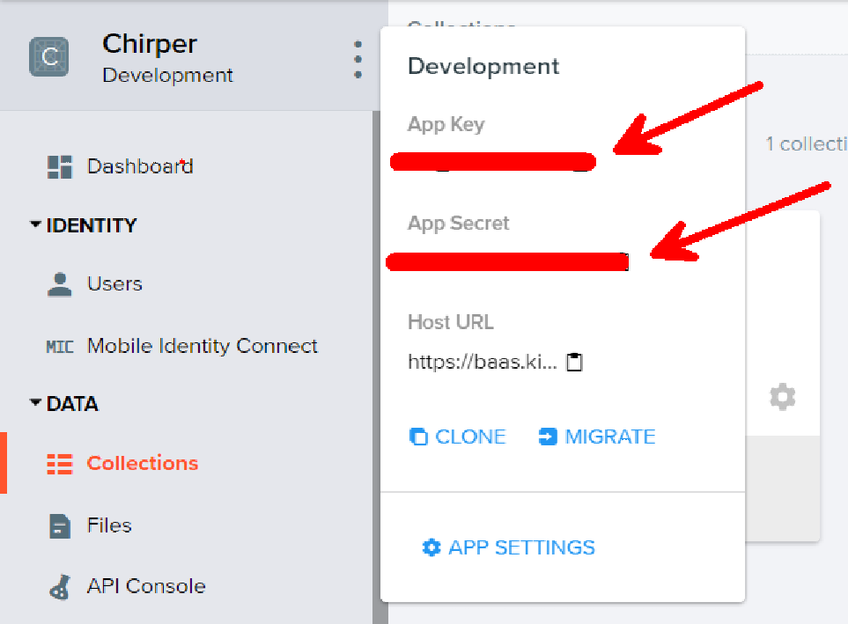

User Login
POST https://baas.kinvey.com/user/app_key/login
Request headers | Authorization: Basic base64(app_id:app_secret)  Content-Type: application/json
Request body | {  "username": "testuser",  "password": "testuserpass890"  }
Response  200 OK | {  "_id": "59930c78a743e20c7d3fca77",  "username": "testuser",  "subscriptions": []  "_kmd": {  "authtoken": "8e6471bc-3712-4cfb-b92e-50e62a0c80….Duj5fHdM /7XHIe6KdY="  …  },  …  }
Error response  401 Unauthorized | { "error": "InvalidCredentials", "description": "Invalid credentials. Please retry your request with correct credentials", "debug": "" }
Successful login returns an “authtoken” which is later used to authenticate the CRUD operations.

User Logout
POST https://baas.kinvey.com/user/app_key/_logout
Request headers | Authorization: Kinvey authtoken
Response
204 No Content
Error response  401 Unauthorized | { "error": "InvalidCredentials", "description": "Invalid credentials. Please retry your request with correct credentials", "debug": "" }
To logout, you need to provide the “authtoken” given by login / register as “Kinvey” authorization header.

List all Chirps by followers (Feed – sorted by post time, descending)
GET https://baas.kinvey.com/appdata/app_key/chirps?query={"author":{"$in": [${subs}]}}&sort={"_kmd.ect": 1}
Request headers | Authorization: Kinvey authtoken
Response  200 OK | [  {  "_id": "59ae7752e884417c04e803a4",  "text": "yohooo",  "_acl": {  "creator": "59ae425c14ee505004862409"  },  "author": "vako",  "_kmd": {  "lmt": "2017-09-05T11:38:02.944Z",  "ect": "2017-09-05T10:07:14.314Z"  }  },…
Error response  401 Unauthorized | { "error": "InvalidCredentials", "description": "Invalid credentials. Please retry your request with correct credentials", "debug": "" }

Where subs is an array of subscriptions (by username).

Create Chirp
POST https://baas.kinvey.com/appdata/app_key/chirps
Request headers | Authorization: Kinvey authtoken  Content-Type: application/json
Request body | {  "text": "MyTestChirp",  "author": "testuser"  }
Response  201 Created | {  "_id": "59931398996ab5127d2a84d1",  "author": "Kiril",  "title": "Test Post",  "description": "Test Post Description",  "url": "https://en.wikipedia.org/wiki/Santorini",…  }
Error response  401 Unauthorized | { "error": "InvalidCredentials", "description": "Invalid credentials. Please retry your request with correct credentials", "debug": "" }

Delete Chirp
DELETE https://baas.kinvey.com/appdata/app_key/chirps/chirp_id
Request headers | Authorization: Kinvey authtoken
Response  200 OK | {  "count": 1  }
Error response  404 Not Found | { "error": "EntityNotFound", "description": "This entity not found in the collection", "debug": "" }
Error response  401 Unauthorized | { "error": "InvalidCredentials", "description": "Invalid credentials. Please retry your request with correct credentials", "debug": "" }

User Chirps (View all chirps by user, sorted by post time, descending)
GET https://baas.kinvey.com/appdata/app_key/chirps?query={"author":"username"}&sort={"_kmd.ect": 1}
Request headers | Authorization: Kinvey authtoken
Response  200 OK | [  {  "_id": "59b004cfdfab74540457702a",  "text": "#testuserchirp",  "author": "testuser",  "_acl": {  "creator": "59affdae3044bb86044a79bd"  },  "_kmd": {  "lmt": "2017-09-06T14:23:11.069Z",  "ect": "2017-09-06T14:23:11.069Z"  }  },..
Error response  401 Unauthorized | { "error": "InvalidCredentials", "description": "Invalid credentials. Please retry your request with correct credentials", "debug": "" }

The next 3 queries are needed to display profile stats.
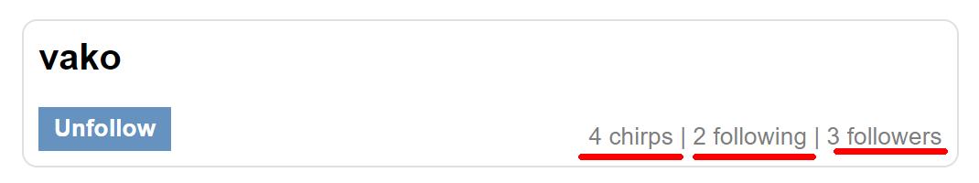

Count Chirps
GET https://baas.kinvey.com/appdata/app_key/chirps?query={"author":"username"}
Request headers | Authorization: Kinvey authtoken
Response  200 OK | [  {  "_id": "59b004cfdfab74540457702a",  "text": "#testuserchirp",  "author": "testuser",  "_acl": {  "creator": "59affdae3044bb86044a79bd"  },  "_kmd": {  "lmt": "2017-09-06T14:23:11.069Z",  "ect": "2017-09-06T14:23:11.069Z"  }  },..
Error response  401 Unauthorized | { "error": "InvalidCredentials", "description": "Invalid credentials. Please retry your request with correct credentials", "debug": "" }

This query will return all of the chirps by given user.

Following
GET https://baas.kinvey.com/user/app_key/?query={"username":"username"}
Request headers | Authorization: Kinvey authtoken
Response  200 OK | [  {  "_id": "59afe6ad68c53f4a045534df",  "subscriptions": [  "vako"  ],  "username": "Kiril98",  "_acl": {  "creator": "59afe6ad68c53f4a045534df"  },  "_kmd": {  "lmt": "2017-09-06T12:37:47.242Z",  "ect": "2017-09-06T12:14:37.861Z"  }  }  ]
Error response  401 Unauthorized | { "error": "InvalidCredentials", "description": "Invalid credentials. Please retry your request with correct credentials", "debug": "" }

This query will return the needed user. The count of the people that the user is following is the length of the subscriptions array.

Followers
GET https://baas.kinvey.com/user/app_key/?query={"subscriptions":"username"}
Request headers | Authorization: Kinvey authtoken
Response  200 OK | [  {  "_id": "59afe70614ee5050048cecfb",  "subscriptions": [  "Kiril98",  "SoftUni"  ],  "username": "kirilvk1",  "_acl": {  "creator": "59afe70614ee5050048cecfb"  },  "_kmd": {  "lmt": "2017-09-06T12:16:19.636Z",  "ect": "2017-09-06T12:16:06.222Z"  }  },  {  "_id": "59affdae3044bb86044a79bd",  "subscriptions": [  "Kiril98",  "Tacito"  ],…  ]
Error response  401 Unauthorized | { "error": "InvalidCredentials", "description": "Invalid credentials. Please retry your request with correct credentials", "debug": "" }

The following query will return all users that are subscribed to given username.

Discover Page
GET https://baas.kinvey.com/user/app_key/
Request headers | Authorization: Kinvey authtoken
Response  200 OK | [  {  "_id": "59ae425c14ee505004862409",  "subscriptions": [  "Tacito",  "SoftUni"  ],  "username": "vako",  "_acl": {  "creator": "59ae425c14ee505004862409"  },  "_kmd": {  "lmt": "2017-09-05T17:14:56.960Z",  "ect": "2017-09-05T06:21:16.793Z"  }  },  {  "_id": "59ae864f603d08cc6fedf3ab",  "username": "Tacito",  "_acl": {  "creator": "59ae864f603d08cc6fedf3ab"  },  "subscriptions": [],  "_kmd": {  "lmt": "2017-09-05T11:42:53.473Z",  "ect": "2017-09-05T11:11:11.629Z"  }  },..
Error response  401 Unauthorized | { "error": "InvalidCredentials", "description": "Invalid credentials. Please retry your request with correct credentials", "debug": "" }

In the discover page you should display all users except the currently logged.

Follow
POST https://baas.kinvey.com/user/app_key/user_id
Request headers | Authorization: Kinvey authtoken  Content-Type: application/json
Request body | {  "subscriptions": [  "testuser",  "vako",  "Tacito"  ]  }
Response  200 OK | {  "subscriptions": [  "testuser",  "vako",  "Tacito"  ],  "_id": "59afe6ad68c53f4a045534df",  "username": "Kiril98",…
Error response  401 Unauthorized | { "error": "InvalidCredentials", "description": "Invalid credentials. Please retry your request with correct credentials", "debug": "" }

The PUT query does not need to include the whole user object. Modify only the subscriptions array.

Unfollow
POST https://baas.kinvey.com/user/app_key/user_id
Request headers | Authorization: Kinvey authtoken  Content-Type: application/json
Request body | {  "subscriptions": [  "testuser",  "vako"  ]  }
Response  200 OK | {  "subscriptions": [  "testuser",  "vako"  ],  "_id": "59afe6ad68c53f4a045534df",  "username": "Kiril98",…
Error response  401 Unauthorized | { "error": "InvalidCredentials", "description": "Invalid credentials. Please retry your request with correct credentials", "debug": "" }

The same query as “Follow”. Only this time we remove the wanted username from the subscriptions array.

Chirper–HTML and CSS
You аre given the Web design of the Chirper application as HTML + CSS files.
- Initially all views and forms are shown by the HTML. Your application may hide by CSS (display: none) or delete from the DOM all unneeded elements or just display the views it needs to display.
- You may render the views / forms / components with jQuery or Mustache Handlebars.
Important: don’t change the elements’ class name and id. Don’t rename form fields / link names / ids. You are allowed to add data attributes to any elements. You may modify href attributes of links and add action/method attributes to forms, to allow the use of a routing library.

Chirper Client-Side Web Application
Design and implement a client-side front-end app (SPA) for managing users and chirps (tweets). Implement the functionality described below.

Notifications
The application should notify the users about the result of their actions.
- In case of successful action an informational (green) notification message should be shown, which disappears automatically after 3 seconds or manually when the user clicks it.
- In case of error, an error notification message (red) should be shown which disappears on user click.
- During the AJAX calls a loading notification message (blue) should be shown. It should disappear automatically as soon as the AJAX call is completed.

Navigation System (5 pts)
Implement a navigation system for the app: navigation links should correctly change the current screen (view).
- Clicking on the links in the navbar or the links on each individual post should display the view behind the link (views are sections in the HTML code).
- Your application may hide by CSS (display: none) or delete from the DOM all unneeded elements or just display the views it needs to display.
- The given navbar should be visible only for logged in users. Anonymous users can only view the sign in/register section.

Register User Screen (10 pts)
By given username, password and repeat password the app should register a new user in the system.
- After a successful registration, a notification message “User registration successful.” should be displayed and the feed page with all chirps by followers should be shown.
- You need to validate the input. A username should be a string with at least 5 characters long. Passwords input fields shouldn’t be empty. Both passwords should match.
- In case of error (eg. invalid username/password), an appropriate error message should be displayed and the user should be able to try to register again.
- Keep the user session data in the browser’s session storage.
- That includes the subscriptions array. Since local/session storage only keeps strings the array must be stringified or kept as a variable and updated on every init.
- Clear all input fields after successful register.
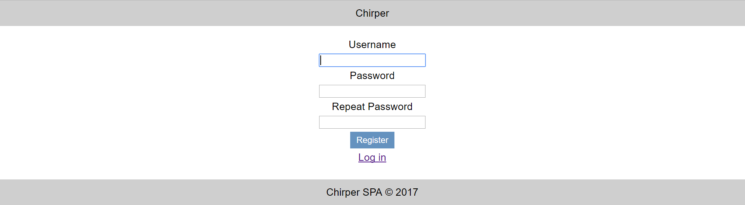

Login User Screen (5 pts)
By given username and password the app should be able to login an existing user.
- After a successful login, a notification message “Login successful.” should be displayed and and the feed page with all chirps by followers should be shown.
- In case of error, an appropriate error message should be displayed and the user should be able to fill the login form again.
- Form validation should be the same as register.
- Keep the user session data in the browser’s session storage.
- That includes the subscriptions array. Since local/session storage only keeps strings the array must be stringified or kept as a variable and updated on every init.
- Clear all input fields after successful login.


Logout (5 pts)
Successfully logged in user should be able to logout from the app.
- After a successful logout, a notification message “Logout successful.” should be displayed.
- After successful logout, the Sign In screen should be shown.
- The “logout” REST service at the back-end should be obligatory called at logout.
- All local information in the browser (user session data) about the current user should be deleted.

Feed/Home Screen (20 pts)
Successfully logged users should be welcomed by the feed screen which can be accessed after clicking the [Home] link in the navbar. The feed screen contains all chirps from subscriptions or people that the user is following (sorted by time posted in descending). It also contains the create a chirp form.
- The chirps should be listed in the format as shown in the Web design (see the screenshot below).
- Each chirp has text, author and information about when it was created. For the time created information you will use a helper function given below. It requires a parameter which is the entity creation date of the post (or _kmd.ect property of the post object).
- When the follower username link is clicked, your app should redirect to the individual feed page of the user.
- The feed screen should also contain information about the count all of all chirps that the user has posted, number of people that the user is following, and number of followers that the user has.
- In case of error (e.g. Internet connection lost), an error message should be displayed.
- In case of no chirps, display ‘No chirps in database’.
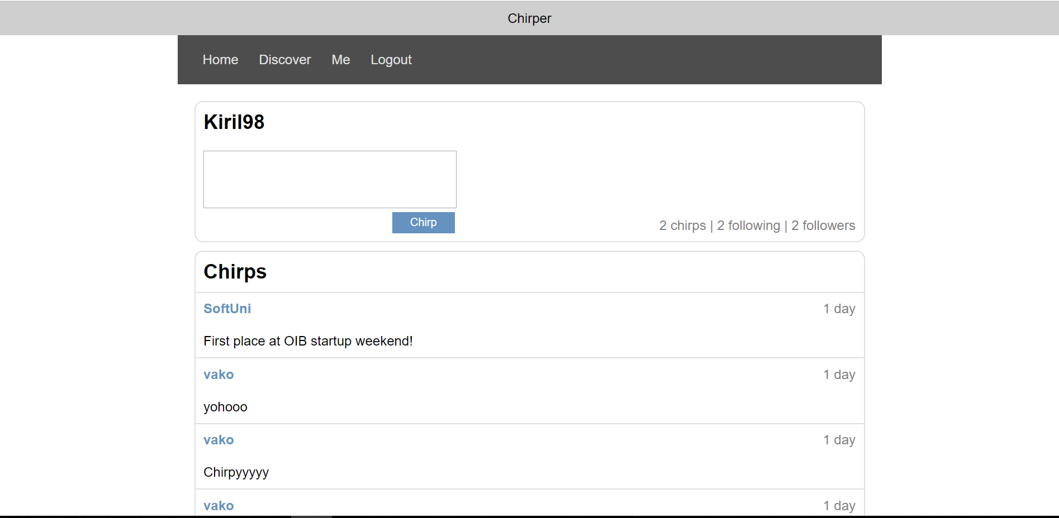
If the user hasn’t follown anyone display the following:
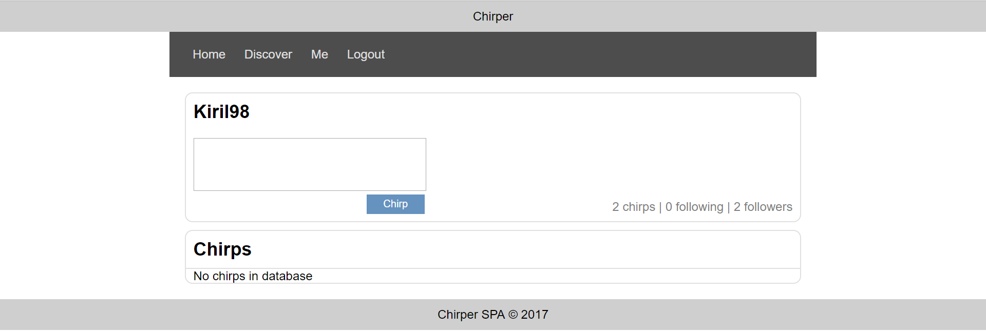
- Format the entity creation date of a chirp as shown in the screenshot above. You may use the following helper function:
function calcTime(dateIsoFormat) {
let diff = new Date - (new Date(dateIsoFormat));
diff = Math.floor(diff / 60000);
if (diff < 1) return 'less than a minute';
if (diff < 60) return diff + ' minute' + pluralize(diff);
diff = Math.floor(diff / 60);
if (diff < 24) return diff + ' hour' + pluralize(diff);
diff = Math.floor(diff / 24);
if (diff < 30) return diff + ' day' + pluralize(diff);
diff = Math.floor(diff / 30);
if (diff < 12) return diff + ' month' + pluralize(diff);
diff = Math.floor(diff / 12);
return diff + ' year' + pluralize(diff);
function pluralize(value) {
if (value !== 1) return 's';
else return '';
}
}
- Ensure you handle properly all HTML special characters, e.g. the message text could hold "Hi, <peter>".

Post Chirp (10 pts)
Logged in users can post chirps. Clicking the [Chirp] button should directly add a chirp into the kinvey database. A chirp has text and author.
- After a successful chirp creation, a notification message “Chirp published.” should be displayed and the user feed should be shown (the screen with all chirps posted by the currently logged user).
- A chirp text shouldn’t be empty and shouldn’t contain more than 150 symbols.
- Clear the create chirp input field after successful creation.
- Ensure you handle properly all HTML special characters, e.g. the message text could hold "Hi, <peter>".
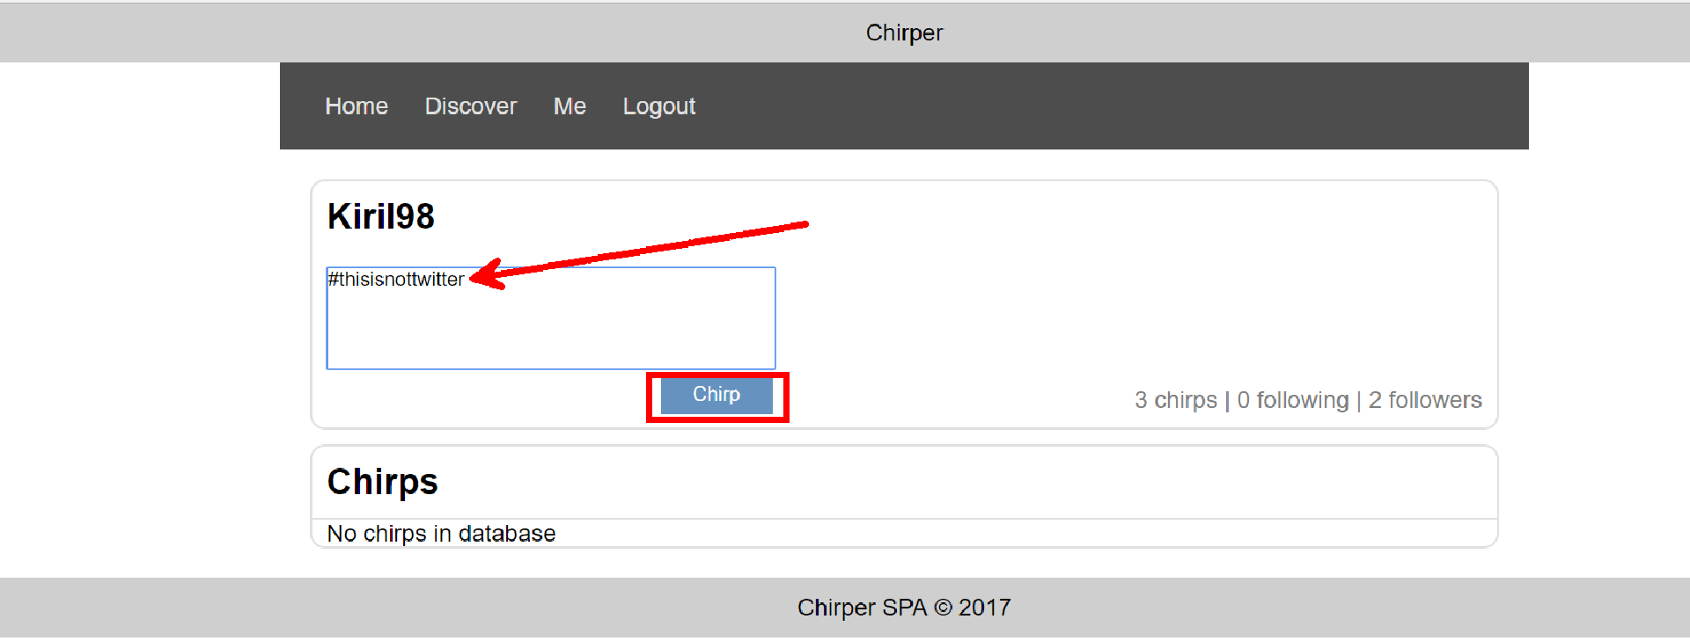
After successful creation the user feed should be displayed. It can also be accessed by clicking the [Me] link in the navbar:
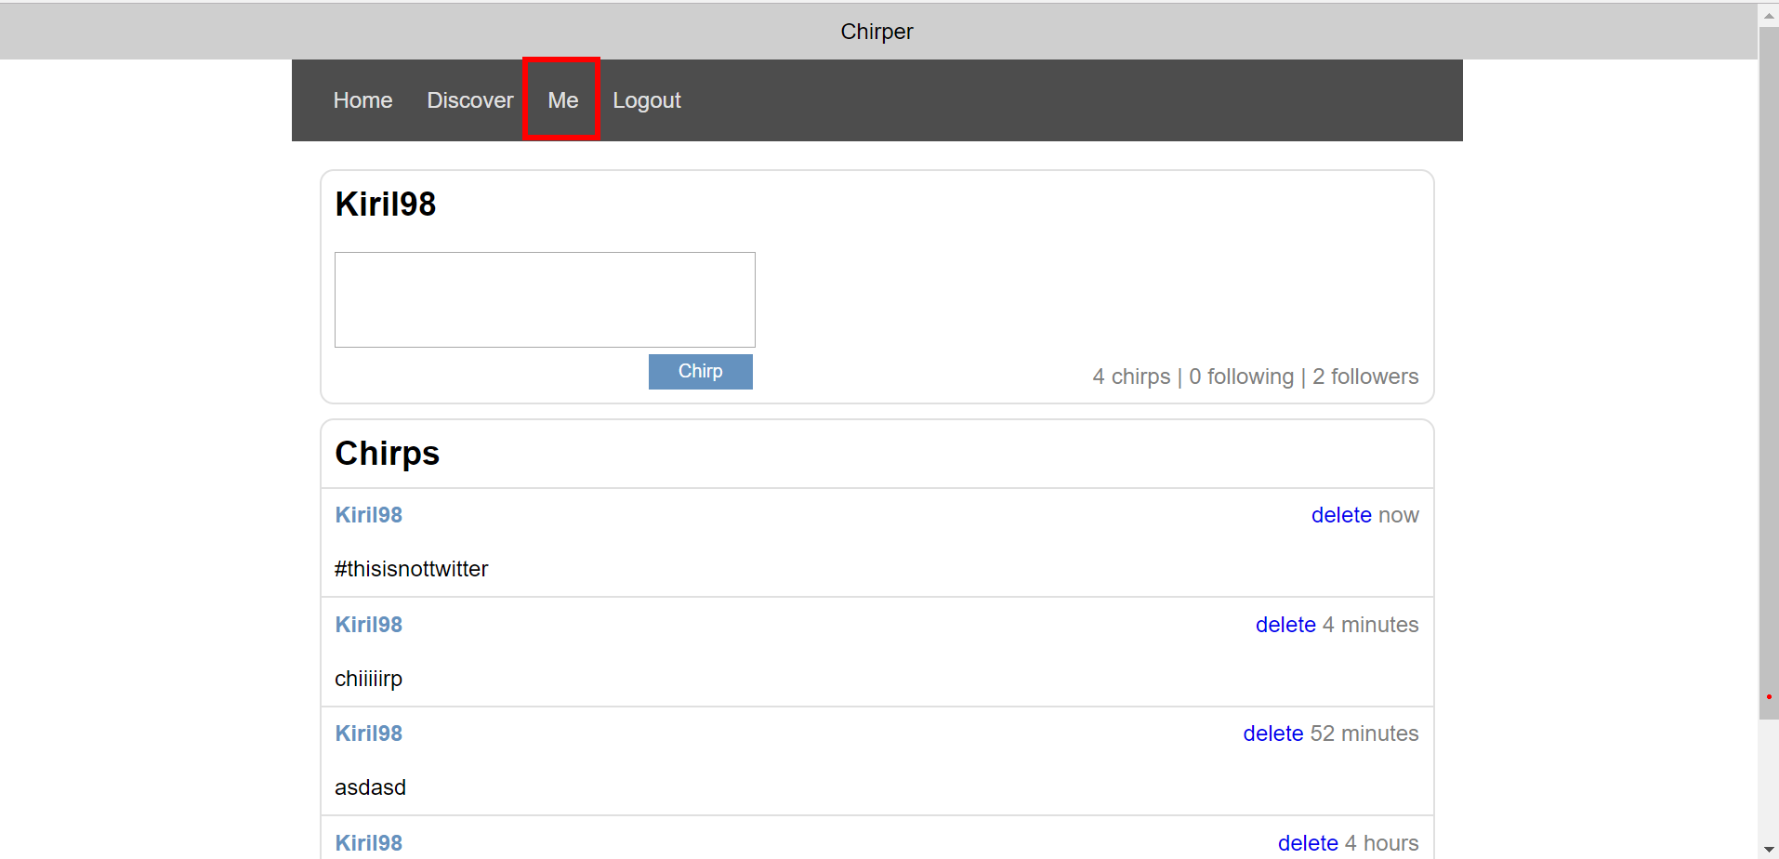

User Feed (15 pts)
Logged in users can view individual feeds (profile page). The currently logged user has an individual feed page where he can view his own chirps, create a chirp and delete his own chirps. Each logged in user can access their own feed by clicking the [Me] link.
- After a successful chirp creation, a notification message “Chirp published.” should be displayed and the user feed should be shown again.
- The user feed screen should also contain information about the count all of all chirps that the user has posted, number of people that the user is following, and number of followers that the user has.
- All chirps are listed in descending by time creation.
- In case of no chirps, display ‘No chirps in database’.
- In case of error (e.g. Internet connection lost), an error message should be displayed.
My feed page:
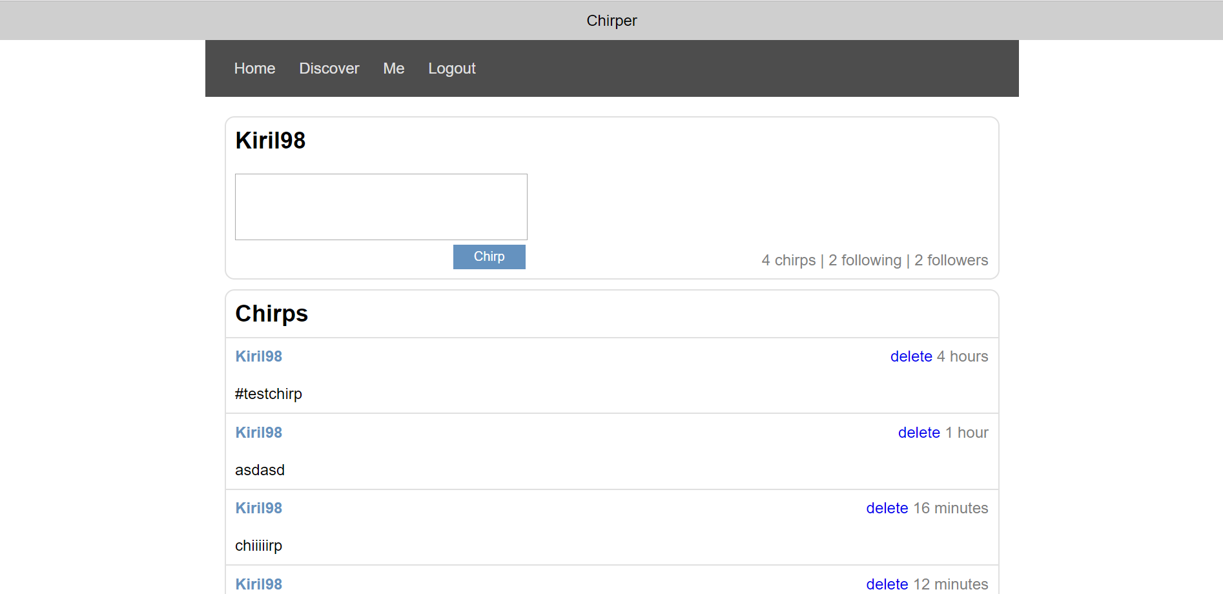
Different user feed page:
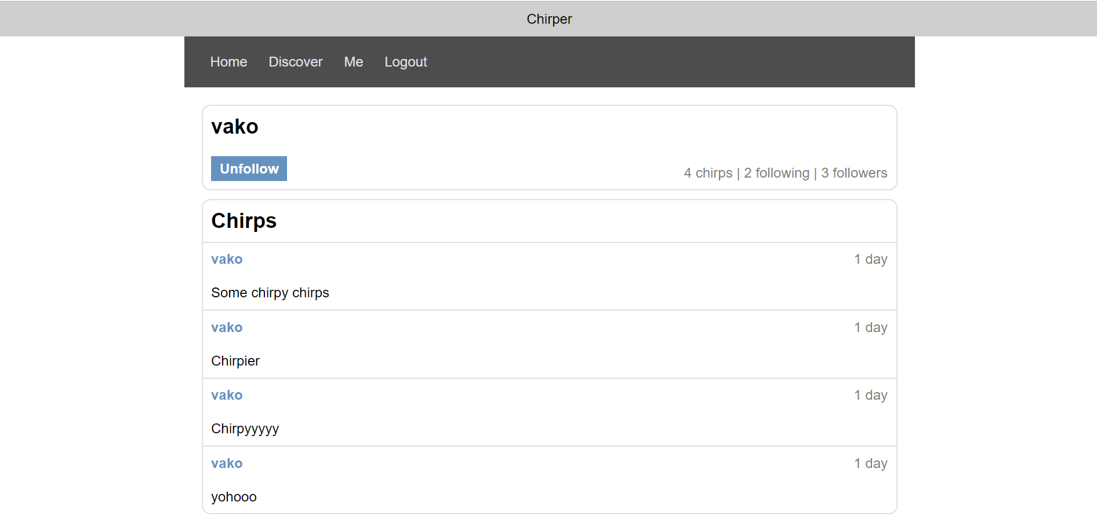
The button on the top left of the screen can be either Follow or Unfollow depending on if the user’s username is in the subscriptions array.

Delete Chirp (5 pts)
Authors should be able to delete their own chirps by clicking the [delete] button on each individual chirp.
- After successful post delete a notification message “Chirp deleted.” should be displayed and the user feed should be shown again.
- In case of error (e.g. Internet connection lost / unauthorized request / missing message), an error message should be displayed.
- Deleting works immediately, with no confirmation.

Discover People Screen (15 pts)
By clicking the [Discover] link from the navigation the following screen should be displayed:
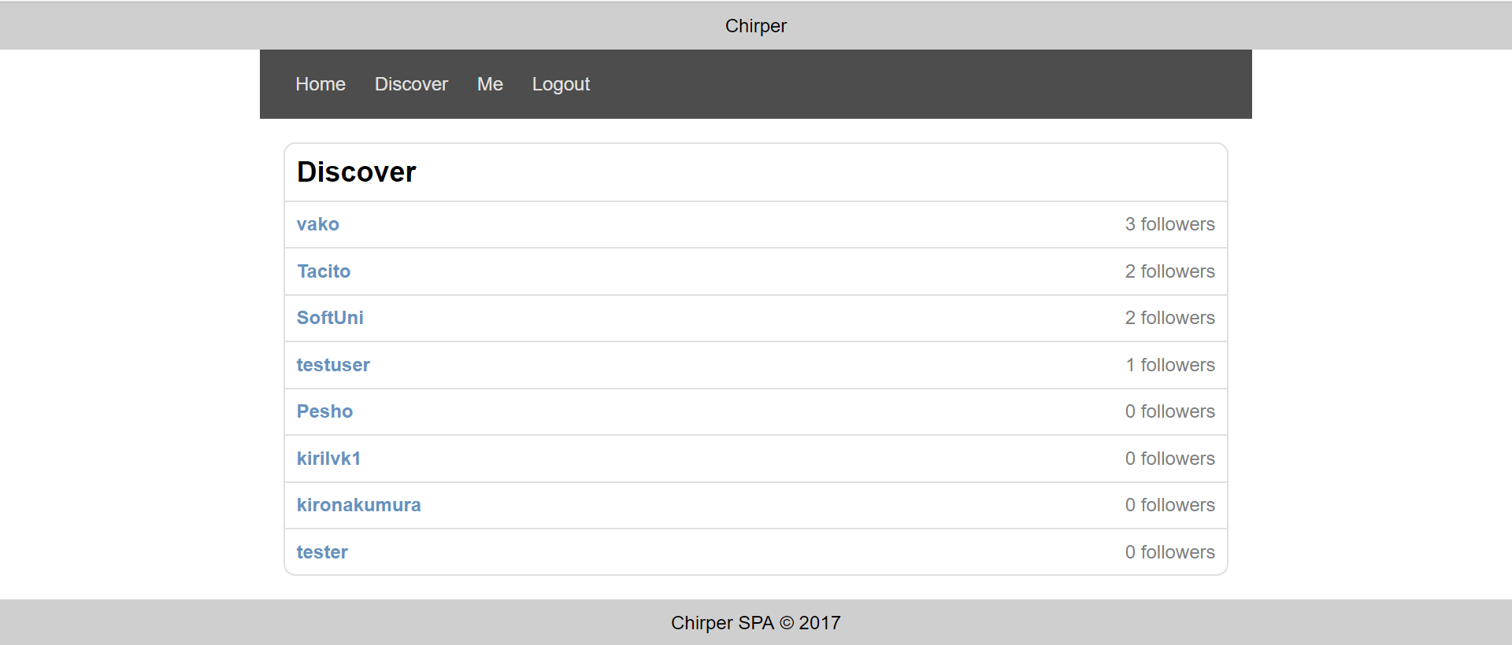
- These are all of the users in the database except the currently logged.
- Clicking on the username should redirect to the user’s feed page
- Next to each username is the number of followers that the user has.
- In case of error (e.g. Internet connection lost / unauthorized request / missing message), an error message should be displayed.

Follow User (5 pts)
Logged in users can follow other users by clicking on the [Follow] link on each user feed page.
- After a successful following, a notification message “Subscribed to {username}” should be displayed and the user feed should be shown again with updated stats.
- The username of the newly followed user should be added in the subscriptions array of the currently logged in user.
- In case of error (e.g. Internet connection lost / unauthorized request / missing message), an error message should be displayed.
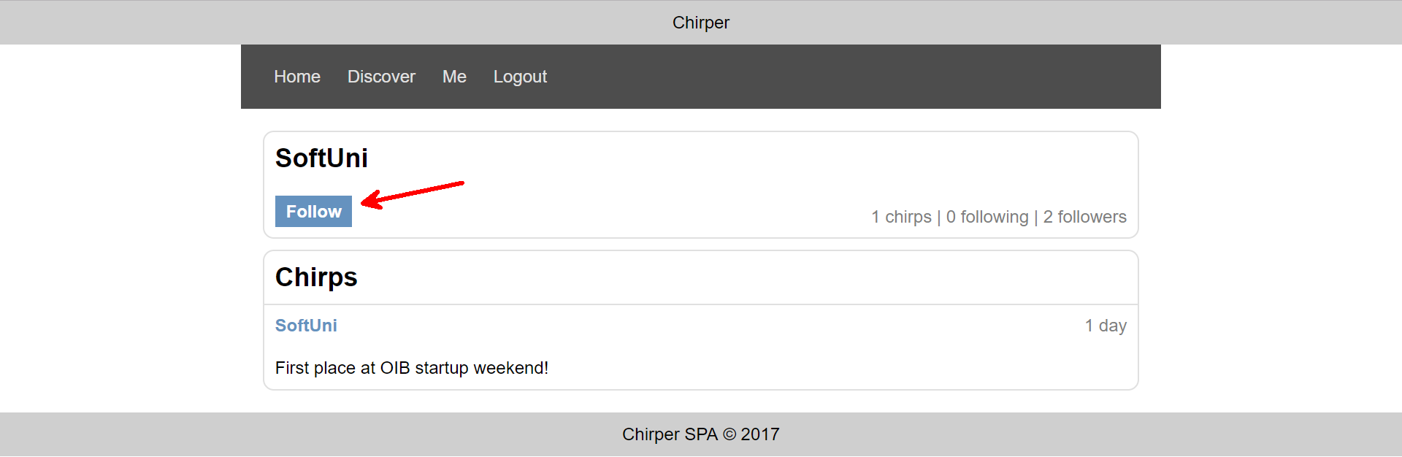
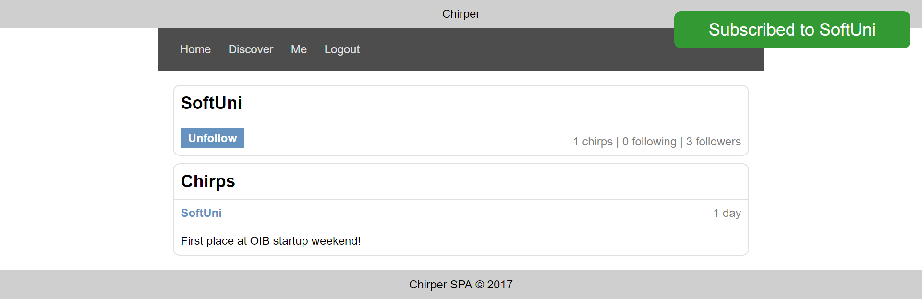

Unfollow User (5 pts)
Logged in users can unfollow other users by clicking on the [Unfollow] link on each user feed page.
- After a successful unfollow, a notification message “Unsubscribed to {username}” should be displayed and the user feed should be shown again with updated stats.
- The username of the newly followed user should be removed from the subscriptions array of the currently logged in user.
- In case of error (e.g. Internet connection lost / unauthorized request / missing message), an error message should be displayed.
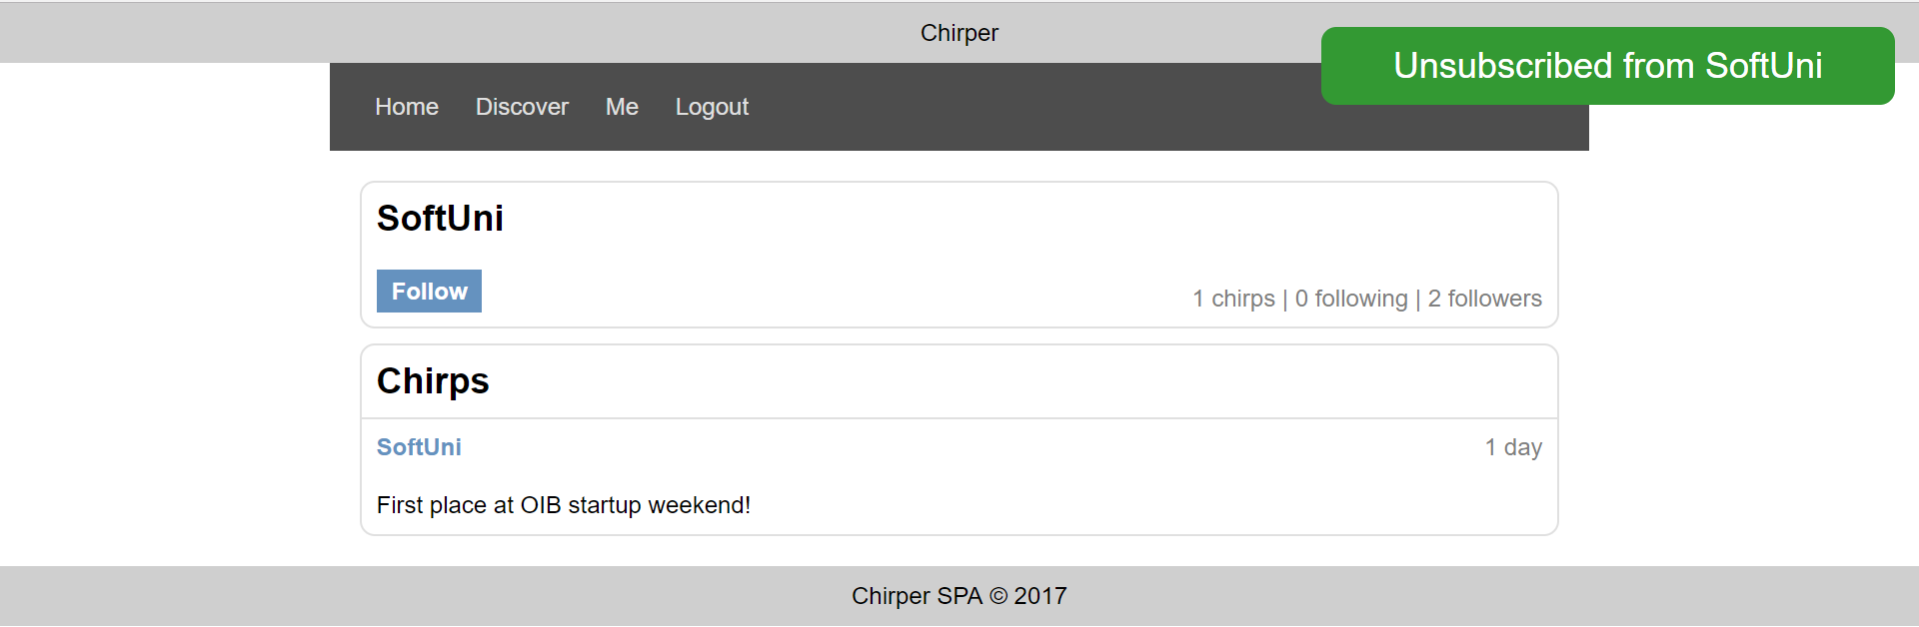

Subtmitting Your Solution
Place in a ZIP file your project folder. Exclude the node_modules folder. Upload the archive to the Judge.

